

## PYTHON PROJECT REPORT

**Pest Detection Management Systems for Agricultural Sustainability**

***Submitted by***

***KANISKA S***

***2303722810622059***

**BACHELOR OF ENGINEERING**

## *in*

**ELECTRONICS AND COMMUNICATION ENGINEERING**

**SRI ESHWAR COLLEGE OF ENGINEERING**

**(AN AUTONOMOUS INSTITUTION)**

**COIMBATORE – 641 202**

**JUNE - JULY 2024**

**BONAFIDE CERTIFICATE**

Certified that this project report **“ Pest Detection Management Systems for Agricultural Sustainability** ” is the bonafide work of

KANISKA S

2303722810622059

who carried out the project work under my supervision

|  |  |
| --- | --- |
|  | …………………………………  **SIGNATURE**  **Dr . V . Kiruthika**  Assistant Professor,  Dept. of Electronics & Communication Engineering,  Sri Eshwar College of Engineering,  Coimbatore-641202. |

|  |  |  |
| --- | --- | --- |
| **CHAPTER NO** | **TITLE** | **PAGE NO** |
| **1** | **INTRODUCTION** |  |
| **2** | **PROBLEM DESCRPTION** |  |
| **3** | **OBJECTIVE** |  |
| **4** | **SOFTWARE SPECIFICATION** |  |
| **5** | **METHODOLOGY** |  |
| **6** | **IMPLEMENTATION** |  |
| **7** | **RESULT** |  |
| **8** | **CONCLUSION** |  |
| **9** | **FUTURE SCOPE** |  |

**TABLE OF CONTENTS**

**INTRODUCTION**

Pest detection and management play a crucial role in agricultural sustainability. Efficient pest management systems help in reducing crop losses, ensuring food security, and minimizing the use of harmful pesticides. Modern technologies, such as machine learning and IoT, have been integrated into pest detection systems to enhance their accuracy and efficiency. This project focuses on developing a web-based application using Flask to report and track pest incidents, ultimately aiding in better pest management and sustainable agriculture.

**PROBLEM DESCRPTION**

Agricultural sustainability is often threatened by pests that can cause significant damage to crops. Traditional pest detection methods are labor-intensive and time-consuming. There is a need for an efficient, user-friendly system that allows farmers to quickly report pest sightings, track pest occurrences, and receive guidance on pest management. This project aims to address this problem by providing a centralized platform for pest detection and management.

**OBJECTIVE**

The primary objective of this project is to develop a Pest Detection Management System that:

* Enables farmers to report pest occurrences easily.
* Stores and manages pest-related data.
* Provides real-time updates and pest management advice.
* Supports agricultural sustainability through effective pest control.

**SOFTWARE SPECIFICATION**

• **Programming Language**: Python

• **Framework**: Flask

• **Database**: In-memory list (for simplicity; can be extended to use databases like SQLite or PostgreSQL)

• **Frontend**: HTML, CSS, JavaScript

• **Libraries**: Flask, Flask-CORS

**METHODOLOGY**

• **Requirement Analysis**: Gather requirements for pest detection and management features.

• **Design**: Design the architecture of the web application, including the frontend and backend components.

• **Development**: Implement the web application using Flask for the backend and HTML/CSS/JavaScript for the frontend.

• **Testing**: Test the application for functionality, usability, and security.

• **Deployment**: Deploy the application on a local server or cloud platform.

**IMPLEMENTATION**

**!DOCTYPE html>**

**<html lang="en">**

**<head>**

**<meta charset="UTF-8">**

**<meta name="viewport" content="width=device-width, initial-scale=1.0">**

**<title>Pest Detection Application</title>**

**<link rel="stylesheet" href="styles.css">**

**</head>**

**<body>**

**<div class="container">**

**<div id="login-page" class="form-container active">**

**<h2>Login</h2>**

**<form id="login-form">**

**<div class="input-group">**

**<label for="login-username">Username:</label>**

**<input type="text" id="login-username" name="username" required>**

**</div>**

**<div class="input-group">**

**<label for="login-password">Password:</label>**

**<input type="password" id="login-password" name="password" required>**

**</div>**

**<button type="submit">Login</button>**

**</form>**

**<p id="login-message"></p>**

**<button id="show-signup" class="toggle-button">Sign Up</button>**

**</div>**

**<div id="signup-page" class="form-container">**

**<h2>Sign Up</h2>**

**<form id="signup-form">**

**<div class="input-group">**

**<label for="signup-username">Username:</label>**

**<input type="text" id="signup-username" name="username" required>**

**</div>**

**<div class="input-group">**

**<label for="signup-password">Password:</label>**

**<input type="password" id="signup-password" name="password" required>**

**</div>**

**<button type="submit">Sign Up</button>**

**</form>**

**<p id="signup-message"></p>**

**<button id="show-login" class="toggle-button">Back to Login</button>**

**</div>**

**<div id="detection-page" class="form-container">**

**<h2>Pest Detection</h2>**

**<form id="detection-form">**

**<div class="input-group">**

**<label for="plant-name">Plant Name:</label>**

**<input type="text" id="plant-name" name="plant-name" required>**

**</div>**

**<div class="input-group">**

**<label for="soil-type">Soil Type:</label>**

**<input type="text" id="soil-type" name="soil-type" required>**

**</div>**

**<div class="input-group">**

**<label for="detected-pest">Detected Pest:</label>**

**<textarea id="detected-pest" name="detected-pest" rows="4" required></textarea>**

**</div>**

**<div class="input-group">**

**<label for="pest-details">Pest Details:</label>**

**<textarea id="pest-details" name="pest-details" rows="4" required></textarea>**

**</div>**

**<button type="submit">Submit</button>**

**</form>**

**</div>**

**<div id="detection-page" class="form-container">**

**<h2>Pest Detection</h2>**

**<form id="detection-form">**

**<!-- Form inputs -->**

**<button type="submit">Submit</button>**

**</form>**

**<div id="detection-result" class="result-container">**

**<p>to resolve the problem follow the steps</p>**

**</div>**

**</div>**

**</div>**

**<script src="script.js"></script>**

**</body>**

**</html>  
  
  
  
from flask import Flask, render_template, request, jsonify, redirect, url_for, session # type: ignore**

**from flask_cors import CORS # type: ignore**

**app = Flask(_name_)**

**app.secret_key = 'your_secret_key'**

**CORS(app)**

**users = {**

**"admin": "password"**

**}**

**pests = []**

**@app.route('/')**

**def index():**

**return render_template('index.html')**

**@app.route('/login', methods=['POST'])**

**def login():**

**username = request.form['username']**

**password = request.form['password']**

**if username in users and users[username] == password:**

**session['username'] = username**

**return redirect(url_for('app'))**

**else:**

**return 'Invalid username or password', 401**

**@app.route('/app')**

**def app():**

**if 'username' in session:**

**return render_template('app.html')**

**else:**

**return redirect(url_for('index'))**

**@app.route('/report_pest', methods=['POST'])**

**def report_pest():**

**if 'username' in session:**

**pest_type = request.form['pestType']**

**soil_type = request.form['soilType']**

**description = request.form['description']**

**pests.append({**

**"pest_type": pest_type,**

**"soil_type": soil_type,**

**"description": description**

**})**

**return jsonify({'status': 'success'})**

**else:**

**return 'Unauthorized', 401**

**@app.route('/get_pests', methods=['GET'])**

**def get_pests():**

**if 'username' in session:**

**return jsonify(pests)**

**else:**

**return 'Unauthorized', 401**

**if _name_ == '_main_':**

**app.run(debug=True)**

**RESULT**

The implementation of the Pest Detection Management System resulted in a functional web application that allows users to report pest sightings and view reported pests. The system successfully stores pest data and provides a user-friendly interface for interaction. Users can log in, submit pest reports, and view all reported pests, aiding in better pest management.

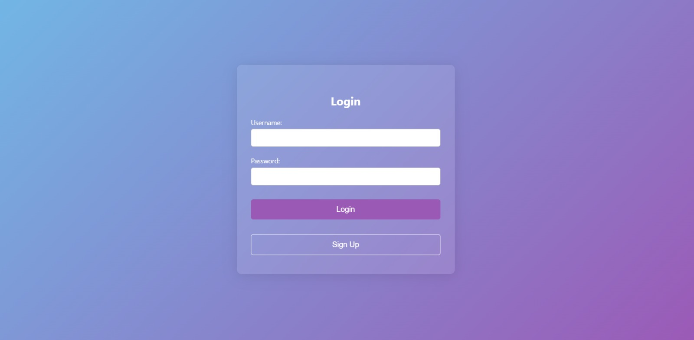

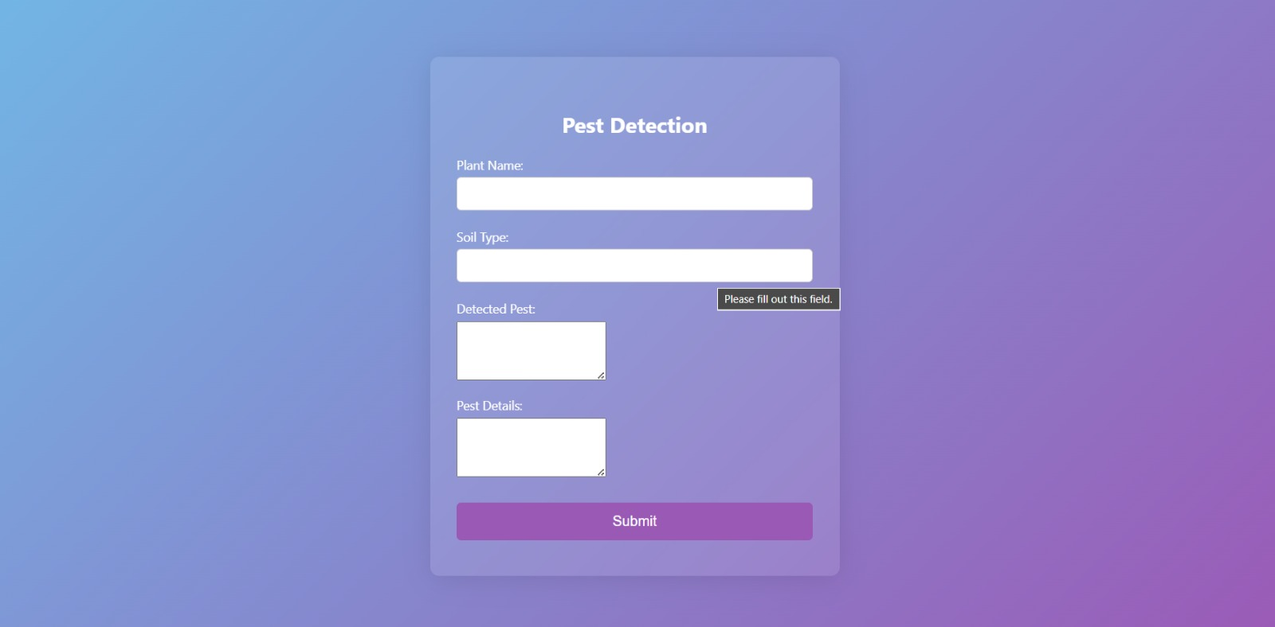

**CONCLUSION**

The Pest Detection Management System developed using Flask provides a practical solution for farmers to report and manage pest sightings. By centralizing pest data and providing timely updates and advice, the system promotes sustainable agricultural practices. The project demonstrates the potential of web-based applications in enhancing agricultural sustainability through effective pest management

**FUTURE SCOPE**

Future enhancements for the Pest Detection Management System may include:

* Integration with a database for persistent storage of pest data.
* Implementation of machine learning models for automated pest detection and identification.
* Expansion of the user interface to include more detailed pest management advice and resources.
* Mobile application development for easier accessibility by farmers in the field.
* Incorporation of real-time pest monitoring using IoT devices and sensors.